**A Prehistoric Scene of Mars in WebGL**

Final Report for CS39440 Major Project

*Author*: Samuel Snowball ([sds10@aber.ac.uk](mailto:sds10@aber.ac.uk))

*Supervisor*: Dr Helen Miles (hem23@aber.ac.uk)

19th April 2017

Version 1.0 (Draft)

This report is submitted as partial fulfilment of a BSc degree in  
Computer Science (G400)

Department of Computer Science

Aberystwyth University

Aberystwyth

Ceredigion

SY23 3DB

Wales, UK

**Declaration of originality**

I confirm that:

* This submission is my own work, except where clearly indicated.
* I understand that there are severe penalties for Unacceptable Academic Practice, which can lead to loss of marks or even the withholding of a degree.
* I have read the regulations on Unacceptable Academic Practice from the University’s Academic Quality and Records Office (AQRO) and the relevant sections of the current Student Handbook of the Department of Computer Science.
* In submitting this work I understand and agree to abide by the University’s regulations governing these issues.

Name: Samuel Snowball

Date: 19/04/2017

**Consent to share this work**

By including my name below, I hereby agree to this dissertation being made available to other students and academic staff of the Aberystwyth Computer Science Department.

Name: Samuel Snowball

Date: 19/04/2017

**Acknowledgements**

I am grateful to the Khronos group for designing WebGL and also to Google and Mozilla for keeping their browsers up to date. Mozilla also has a great tutorial series on the basics of WebGL, including various pages of documentation.

I’d like to thank my supervisor Dr Helen Miles for assigning me the project and also for her continuous support throughout.

Last but not least I’d like to thank Greg Tavares for his tutorial series WebGL fundamentals and also his m4.js matrix math library.

**Abstract**

A prehistoric scene of Mars created in WebGL (Web Graphics Library), GLSL (OpenGL Shading Language) and JavaScript. The scene allows users to roam around and explore Mars as it existed in its Noachian period, around 4 billion years ago. The project uses some features of WebGL (2.0) which are only available in Chrome and Firefox.

You can check if your browser can run the project here:

http://webglreport.com/?v=2

The original aim of this project was to create an interactive Mars mission control game, where the user would roam around Mars as a rover completing various tasks. The project direction changed after the mid project demonstration, It became clear I did not enjoy creating the game aspects of the project, so I decided to just focus on the graphics instead.

My motivation for the project was to learn how computer graphics work. At the start of this project I had next to no experience with GLSL and no experience with WebGL. Learning these new languages whilst going along was challenging, however my desire to learn outweighed the problems I faced.

Programming in WebGL will help me gain an understanding of what’s actually going on at the low level, to get graphics to display on the screen. Learning WebGL is useful due to its flexibility running on various different operating systems, rather than an alternative like Direct3D, which only runs on Windows.

I haven’t been able to find a similar project built like this before. This is mainly due to it being in 3D and the low level languages used.

**Contents**

1. Background, Analysis & Process 3

1.1. Background 3

1.2. Analysis 3

1.3. Process 3

2. Design 3

2.1. Overall Architecture 3

2.2. Detailed Design 3

2.2.1. Even More Detail 3

2.3. User Interface Design 3

2.4. Other Relevant Sections 3

3. Implementation 3

4. Testing 3

4.1. Overall Approach to Testing 3

4.2. Automated Testing 3

4.2.1. Unit Tests 3

4.2.2. User Interface Testing 3

4.2.3. Stress Testing 3

4.2.4. Other Types of Testing 3

4.3. Integration Testing 3

4.4. User Testing 3

5. Critical Evaluation 3

6. Appendices 3

A. Third-Party Code and Libraries 3

B. Ethics Submission 3

C. Code Samples 3

Annotated Bibliography 3

# Background, Analysis & Process

## Background

The original project involved making a game which was something I had some experience in so I was immediately drawn to it. I had created some simple 2D games in the past, however I wanted this project to be in 3D. After the mid-project demonstration I switched the project from a game, to a graphical scene.

3D graphics had always fascinated me, how could you display 3D objects on a 2D screen? I had some experience in 3D graphics with game engines and libraries, but I never found enjoyment in using them. These tools covered up the details of how the scene was actually being displayed, which was the main thing I always wanted to learn. I wanted to dive deeper than just dragging objects into a premade 3D scene, adding textures and then hitting play.

I was interested in low level graphics before the project came out and gained some experience in OpenGL (Open Graphics Library) over Christmas. I knew regardless of if I got this project, developing low level graphics was a skill I wanted to have. Luckily I got assigned this project, and with my head start in graphics programming I was confident to start.

## 1.1.1. Related Projects

NASA had developed a Mars rover game. Unfortunately there wasn’t anything I could learn from this as it had obviously built in a rush, being 2D and lacking game playability.

As WebGL is a very new technology, there haven’t been very many games or projects created in it, at least not from scratch. However as WebGL is based off OpenGL, most OpenGL projects are useful learning resources. The main project that inspired this one was a first person game in OpenGL. It was created by the youtube user OneGoldenCat. The great thing about this project is that it is open source and well commented.

//reference this https://www.youtube.com/watch?v=aviL3HX3UEc&t=267s

## 1.1.2. Language Research and Comparison

There was a variety of options to develop the scene. Game engines, libraries and raw graphics libraries where all available options. However, complex engines and libraries covered up the details of how the graphics actually get displayed.

Using game engines like Unity or Unreal would have created a very realistic looking scene. They were designed to make creating games as fast and as painless as possible. Most engines will handle: user input, sound, rendering, memory management and many more features for you. Most often, engines will have sub-engines, handling complex physics and collision detection. Having all of these pre-built features allows you to simply focus on building the game, rather than the engine behind it.

Engines are powerful, if you know how to use them. They require lots of time to be able to use them effectively. It might take too long to complete the project after learning how to use an engine. Engines also require lots of memory, have long installation times and are very computationally expensive. As this was a relatively small project, rather than an AAA sized game, the overhead of using an engine was not worth it. With a game engine there is also less flexibility, you can’t fix bugs or render more efficiently (unless it’s open source).

Game engines have their place, and you would rarely write a game in the industry without one. However for learning purposes, developing this project at a lower level was the best way to go.

Mid-weight graphics libraries exist giving you a lower level option than game engines. Three.js is an example of this. It is a 3D JavaScript library for rendering graphics within a browser, using WebGL at its back end. These libraries are much lighter weight than full game engines, but still cover up the details of the graphics get displayed.

A lower level option was Direct3D, which is an API built to render graphics on Windows machines. If you wanted to create a game or display graphics with this on multiple platforms, you can’t. Still, most games are written in Direct3D due to its solid Microsoft framework and developer toolsets. It can make use of the other DirectX libraries such as (DirectSound) as well. There are more flexible alternatives than Direct3D and it offered no benefits to the project.

Vulkan is another API for rendering graphics. It is new and much lower level than OpenGL, meaning it will run more efficiently on the hardware. It has a much cleaner API than OpenGL, which has had things thrown on top of it ever since its introduction in 1992. As Vulkan is very low level, it would be extremely difficult to learn with no real graphics knowledge. Because of this, it wasn’t suitable to use for the project.

A more flexible alternative is OpenGL, which is a C API for rendering graphics on desktops. Unlike Direct3D, OpenGL can run on various different operating systems such as: Windows, MacOSX, Linux and UNIX. This means OpenGL applications are highly portable. This is the biggest reason why OpenGL is the most widely used and supported choice for graphical applications. OpenGL has been around for 20 years, having many stable releases, good tutorials and proper documentation.

Using OpenGL for graphics requires you to use a base language of C++. However there was an alternative to OpenGL called WebGL. This is a JavaScript API for rendering graphics within a browser and is based off an older version of OpenGL. This means the base code of the project would be in JavaScript, rather than the base code being in C++ using OpenGL.

The graphics aspect alone will be difficult for this project, therefore having a good knowledge of the base language is critical to the project’s success. If the base code was poor, then the graphics would suffer as well. C++ is a complex language to use, handling your own memory and pointers are just a few of the main examples. JavaScript on the other hand is a beginner friendly language, meaning the WebGL graphics would be easier to write on top of it.

The standard graphics APIs like OpenGL and Direct3D would have been perfect if C++ was a forgiving language. However the benefits of these APIs did not matter as I couldn’t use C++ effectively.

All graphics APIs use some form of shader language. A shader is a program than runs on the GPU, processing data that you give to it. GLSL (OpenGL Shading Language) is used with OpenGL and is therefore used in WebGL.

Hence the final languages I decided to use where: WebGL, GLSL and JavaScript.

## 1.1.3. WebGL

WebGL is based off OpenGL ES 2.0 (an old version of OpenGL for Embedded Systems). This means it lacks many features of the modern graphics libraries such as OpenGL and Direct3D. These other graphics APIs are much better documented and have more learning resources than WebGL, as they have existed longer. WebGL was designed to run within browsers, rather than other libraries which run on desktop.

## 1.1.3.1. WebGL Requirements

To run WebGL scenes, up to date hardware and graphics drivers are required. As WebGL runs within a browser, an update to date version of the browser is required. But still, having an update to date browser might not be enough. As WebGL itself is just a specification (not an actual implementation) it is up to browser companies to implement WebGL themselves.

Modern OpenGL can use a GLSL version of up to 4.40. However the more up to date GLSL version used, the more is required from the hardware. This means if a program is using GLSL version 4.40, it will not be supported on as many devices as an older version. As WebGL uses GLSL ES version 1.00, it is supported on the vast majority of hardware. WebGL was essentially built to run anywhere. Its 1.0 version will run on mobile, tablets, IOS, Android, Chrome, Firefox, Edge and Safari. All of this happens with no plugins or installation.

WebGL 2.0 was officially released in April 2017, therefore most browsers haven’t implemented the full specification fully. Internet Explorer, Edge and Safari are all examples of browsers that lack up to date versions of WebGL. For this reason, my project only runs in Chrome and Firefox.

## 1.1.3.2 Benefits of WebGL

Although WebGL is low level, it has many advantages over alternative approaches. It has no heavy engine which means scene loading times are much faster. It is also less computationally expensive as all you need is a browser, rather than a full game engine or library. WebGL requires no installation or heavy loading times, making it much better for the end user.

As WebGL is essentially developing graphics from scratch (or as low level as you would ever want to go), you have to understand what you’re doing to use it effectively. With game engines, you don’t have to understand how anything works to create some objects in a 3D scene. This means WebGL is a great learning tool as you have to learn the most important aspects of graphics first. For example the engine components of a 3D scene all need to be build first, before worrying about any other less important features (lighting, texture effects).

WebGL (or graphics in general) has many uses such as: games, simulations, augmented reality and data visualization.

## 1.1.3.3. Benefits of working within a browser

WebGL runs within a browser. So when working with WebGL, you get all of the benefits of working within a browser. HTML5 has very easy APIs to tap into such as audio, local storage, text rendering and methods to easily get user input.

If I didn’t switch the project direction from a game to a graphical scene, then easy access to networking would have been useful for multiplayer. Libraries like socket.io are extremely easy to get two clients communicating with a server exchanging data. Because of libraries such as socket.io, it’s easy to interoperate with web applications due to the ease of networking. You can also get resources at runtime from URLs instead of having large amounts of memory pre allocated for textures and video.

Web applications are also easier to test. Just test on one, or a few, browsers and that’s all you need. You no longer need to test on multiple different operating systems. If your application works fine on chrome in Windows, then it will work exactly the same in chrome on Linux. The operating systems don’t matter, it is all within the browser. Browsers are accessible through most devices, phones, tablets, laptops, essentially anything with an internet connection. More often than not they are lighter weight than desktop applications. All you have to do with a WebGL scene is just open the page, no installation or download needed.

## 1.1.4. Coordinate systems overview

We define a cube with some vertices, then use a 4x4 matrix to position it in our world. This positioning, or translation, is done via the model matrix. Rather than thinking of it as the model matrix, it is easier to think of it as the model to world matrix, as the matrix moves our model into the world. This world coordinate system contains all of our objects. Just imagine two coordinate systems within one another. The image below shows just that:

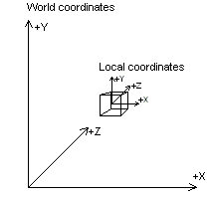

// credit image

We then look at the world from the view of the camera. This is called the view matrix but again, it’s easier to think of it as the world to view matrix. As the entire world gets moved in front of the camera.

Finally, to display the world on the screen we need to convert our 3D virtual world into 2D screen space. After all, how is it possible to display a 3D point on a 2D screen? The answer is, it is impossible. We need to pass the screen, or frame buffer, 2D coordinates to display. The 3D to 2D conversion is done via a projection matrix.

## 1.1.4. Coordinate systems in-depth

Imagine you have a 3D cube. All of its vertices are defined with respective to the cubes origin at (0x, 0y, 0z). This is called the objects coordinate system, also known as the model coordinate system. For every new object, its vertices are defined relative to its own origin.

Now you have that cube, imagine you want to position it in the game/scene world. To do this, translations need to be applied to the vertices of the cube. These translations can be done by applying 4x4 matrices to the vertices of the cube. Matrices are used as they can combine several operations into one matrix, rather than having to apply operations to the vertices individually. For example a singular matrix can contain: where the point should be positioned, how it should be rotated and how it should be scaled.

//not correct? … The original 3D points needs to be converted into 4D points before doing so. The forth column holds the values needed for translation.

The below image shows a 4D point that we want to move. To do this, it gets multiplied by a translation matrix. The output on the right is the points new position.

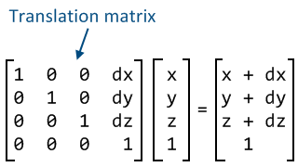

//credit this image

Not only can we use matrices to move the vertices of an object, but we can also use them to scale the vertices as well. The below image shows how you can scale an object by using a scaling matrix. This takes in (Sx, Sy, Sz) which is a 3D vector containing the scale values for each (x, y, z) point of the vertex. For example if we wanted to scale an object by 2 in all x, y and z directions, the scaling vector would be (2, 2, 2).

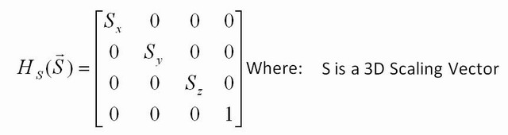

Lastly, rotation matrices can be applied to vertices

By performing these translations, the cube is now in the world’s coordinate system.

A benefit of matrices is instead of multiplying them all together then lastly with the vertex, like so: translationMatrix * scaleMatrix * rotationMatrix * vertex. You can instead just multiply all the matrices together once, and apply that single matrix with each vertex of the model. This saves multiplying the matrices together for each point you want to translate. The final matrix containing the translation/scale/rotation values is usually called model matrix, or the full transforms matrix.

When multiplying matrices together you need to be careful, as multiplying them in different orders yields vastly different results. The usual way is: scale, rotate then translate, which in code looks like:

matrix4 fullTransforms = translate * rotate * scale (read from right to left).

This is the usual case as you would want to rotate and scale the object about its origin, rather than about the point after you have done the translation.

The below image shows a cube, in its own coordinate system, that we want to move into world space. This is done by applying a model matrix containing the combination of the translation/scaling/rotation matrices as explained above. After this is done, the model is in the worlds coordinate system. This is where all objects in the scene are placed. The objects have their own coordinate system, starting from their origin, but we position them into the world’s coordinate system. This is so all objects are now defined with the same origin (0x, 0y, 0z). If all objects are within the same coordinate system (worlds) then it’s easy to move all of them at the same time. This is useful for moving the world, looking like the user is moving within the world.

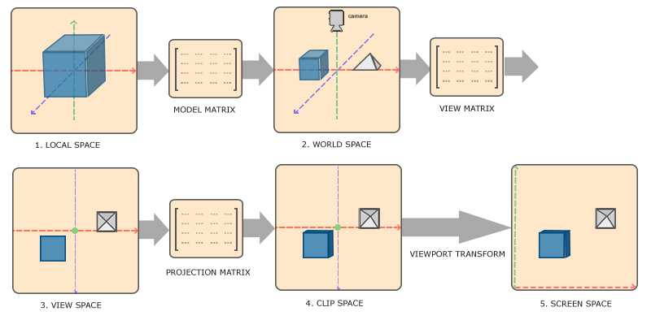

A camera matrix is then used to move everything in the world in front the camera. The camera is defined and has its own position and orientation in the world, just like a regular object. We want to render everything in front of where the camera is looking. However a step the below diagram misses out is creating the view matrix, by taking the inverse of the camera matrix. This moves the entire world in front of the camera, as this is actually what happens in graphics.

The projection matrix takes the world coordinates, and squishes them to clip space coordinates. These clip space coordinates range from -1 to +1 in all x, y, z spaces. A perspective division is done

View to projection (NDC) done with projection matrix. Multiply by projection matrix = Clip space, then perspective divide (divide by w) = NDC coordinates

//where does the 3d to 2d conversion happen

// https://learnopengl.com/#!Getting-started/Coordinate-Systems

## 1.1.4. Fixed function VS programmable graphics pipeline

WebGL uses something called the programmable graphics pipeline, as opposed to the old fixed function pipeline. This newer pipeline was implemented into versions of OpenGL including and after 2.0. Hence the new pipeline is in WebGL, as it uses OpenGL ES 2.0. This pipeline is just the series of steps needed to take some data and display it on the screen.

In the old fixed function pipeline it was very one size fits all and not customizable. There was no functionality for doing any custom calculations (lighting/fog), only what was built in. You could opt in for the features that you wanted, for example the pipeline should calculate fog, or you could opt out and not use them. However there was no functionality allowing you to customize the operations, only ones to enable or disable them.

But now, using the new programmable pipeline, it allows you to write programs called shaders which replace parts of the graphics pipeline. Shaders are programs which are written in GLSL. This is a C style language which allows you to specify how your data should be manipulated on the graphics card.

These shaders allow programmers to manipulate the data how they want, giving you much more power over what gets rendered. The disadvantage of these shaders is that they add complexity to application, as you now have to manage some stages of the graphics pipeline yourself. For simple applications which aren’t going to do any fancy graphics, then an older version of OpenGL (pre 2.0) would better suit your needs, as it uses the fixed function pipeline without customizable shaders.

## 1.1.4.1. Programmable pipeline

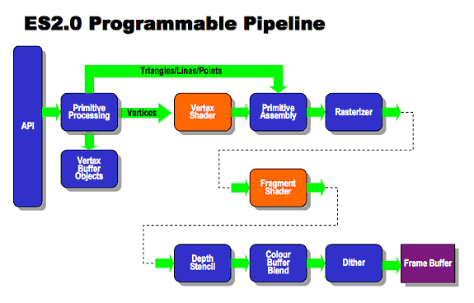

Before I explain the details of the pipeline, it is important to understand that there is not just one of these pipelines which everything goes through. There are usually a few thousand of these programs running in parallel on the graphics card. Each of them processing a vertex/pixel at a time. This is why GPUs are used for graphics, due to them being able to process a large amount of data in parallel.

The scene data (vertices, colours, normals etc) are created by the programmer on the CPU. The data then gets passed to the WebGL (the API component on the left) through the calls to the API. WebGL then takes care of passing the data through the graphics pipeline, all on the GPU. As WebGL uses the programmable pipeline, it’s the programmer’s job to replace the vertex and fragment shaders (highlighted in orange in the above diagram).

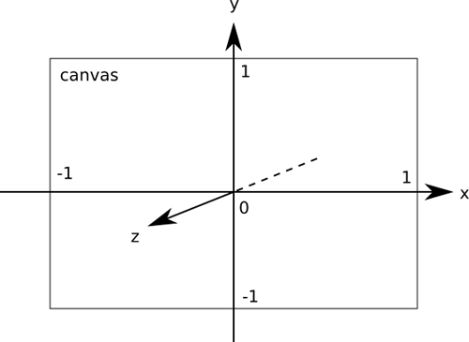

In this example, the triangles vertices will be defined in screen space. The WebGL screen space coordinate system is shown in the right image:

Stage 1 – Data input/data binding

Take the triangle in the image to the left.

The vertices would be as follows:

var vertices = [

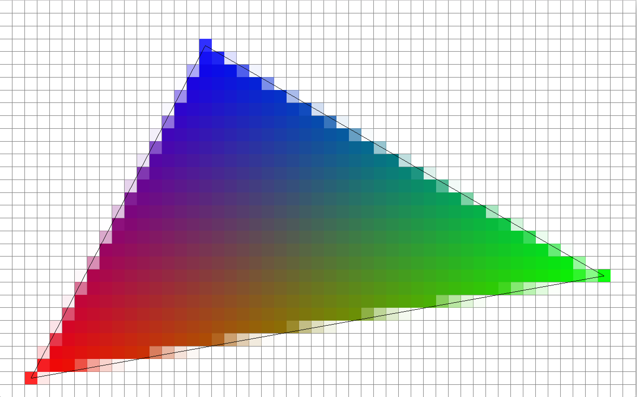

(-0.3x, +0.8y, +0.0z), // top middle vertex

( -0.9x, -0.9y, +0.0z), // bottom left vertex

(+0.8x, -0.3y, +0.0z) // bottom right vertex

];

The colours for each vertex also need to be defined.

var colours = [

(0 red, 0 green, 255 blue), // top middle

(255 red, 0 green, 0 blue), // bottom left

(0 red, 255 green, 0 blue) // bottom right

];

For WebGL to draw something, you have to provide that data and then tell WebGL how to connect the data and then finally how to draw it. Take the triangle vertices in the above example. These needs to be put into memory on the GPU and this is done with a call to gl.bufferData(). This process of uploading data to the GPU is slow, so should be minimized in render loops. The data then needs to be selected from the GPUs memory at render time with a call to gl.bindBuffer() before issuing the draw call.

Stage 2 – Vertex shader

//old The vertex shader (left component in red in above diagram) will get run for each vertex (3 vertices in this example). The triangle will be constructed from the given vertices. Now we have a constructed triangle, it needs to be filled with colour. This is where the fragment shader gets run. For every pixel within the triangle the shader will be executed to set the colour for each pixel.

The programmer’s custom vertex shader is then called for each vertex being processed. You can also input 4x4 matrices into the this shader to say where and how the vertices should be positioned.

The vertex shader outputs the game/scene coordinates in clip space, ranging from -1 to 1 in x, y, z. However at this point they have no colour, so it ignore the colour in the below diagram.

Once the clip space coordinates of the vertices have been calculated, the shader will clip or cull any vertices that are fully or partially outside of the view of the frustum.

In the below diagram (ignore all colour for now), if any of the shapes where outside of the viewing frustum, then they get culled. This means the entire object is discarded as the user can’t see it. It’s important to get rid of any unnecessary vertices as early as possible, if the user can’t see them – why waste time processing them through further stages of the pipeline? If the shape is partly in view, then the vertices that are out of view get clipped and recalculated, then only the visible parts of the objects remain.

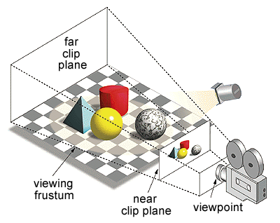

After the vertex shader has culled and clipped any out of range vertices, a step called perspective division happens which turns the 3D frustum (shown above) into 2D screen space. Essentially this squishes, or projects, the 3D scene into a 2D image so it can be displayed on screen (as shown above). Now we have some colourless shapes on the screen, they need to be filled with their colour.

Stage 3 – Primitive assembly

Depending on the draw call that was issued, WebGL will form different primitives from the given vertices.For example with draw call: gl.drawArrays(GL.TRIANGLES) WebGL will construct a triangle between every 3 vertices given. There are also other drawing modes such as GL.POINTS and GL.TRIANGLE_STRIP.

Stage 4 – Fragment shader

As you can see with the colours defined above, we only have 3 colours for the entire triangle. If we were to give colour information for each pixel, this would require a huge amount of data. So instead we just define colours for each vertex. WebGL then interpolates (blends) between the colours of the vertices. You can see this by looking at the points in the middle of the triangle, their colour is blended between all of the vertices colours. This is only noticeable when a triangle is this big, usually objects are made of thousands of triangles so the user wouldn’t notice this interpolation.

The programmers custom fragment shader, part of rasterization (or colouring in) stage of the pipeline then gets run and sets the colour of he fragments between the defined vertices on the 2D image. A fragment, just means a potential pixel. The fragment hasn’t been tested properly to see if it’s visible, so it might not get rendered. Pixels are things that appear on the screen, a fragment might not. For example a fragment could be replaced by another fragment that is closer to the camera.



The fragment shader runs for each fragment within the given object and outputs an (R,G,B,A) value. However this calculated colour might not appear onto the screen.

Stage 5 – Fragment testing, the depth buffer

What if we calculate the fragments/colour values for an object (take the blue pyramid in the above example) – but then calculate another objects colour that is in front it (take the yellow sphere in the above example). The object that is closer to the camera needs to get rendered on top of something that’s behind it. So in this case, the yellow sphere should partly render over the blue pyramid. There needs to be some sort of test to see which objects are closer than others. This is where the depth buffer comes in handy.

//depth values are probably wrong here

The depth buffer stores all of the depth information for the entire scene, it’s just a huge 2D array. For example the blue pyramids vertices would be stored with a depth of around -0.5. The yellow spheres vertices would be stored with a depth value of around +0.5, meaning they’re closer to the camera. This information is used to determine what the colour of the fragments should be. As the yellow sphere is closer, its fragments are chosen over the blue pyramids fragments.

Now the fragment shader has run for every fragment and has finished. All of these fragments are stored into the colour buffer, which is another huge 2D array of pixels. The fragments turn into pixels here as they’re no longer potential pixels, but actual pixels. Their depth has been tested and they’re definitely going to be rendered this frame.

Stage 6 – Updating the frame buffer

The frame buffer is the final 2D image that’s displayed on the screen. It consists of the depth colour buffers.

Once all objects in the scene have been added to the colour buffer, it can be swapped with the current frame buffer to show the newly updated frame. This technique is called double buffering. The pixels don’t render onto the screen directly as it would result in parts of the scene being drawn before others. It’s better to wait for the entire scene to be rendered to an off screen buffer, before swapping it with the current frame buffer.

All of the vertices and data in my scene goes through this graphics pipeline, ideally upwards of 30 times per second, for 30FPS.

// add in full code of uploading data to GPU, binding buffer, explain each line etc

// similar calls throughout entire project

## 1.1.X. Learning resources

To start learning OpenGL I used:

<https://www.youtube.com/watch?v=6c1QYZAEP2M&list=PLRwVmtr-pp06qT6ckboaOhnm9FxmzHpbY>

<http://www.opengl-tutorial.org/>

https://learnopengl.com/

To start learning WebGL I used:

<https://webglfundamentals.org/>

## Analysis

Taking into account the problem and what you learned from the background work, what was your analysis of the problem? How did your analysis help to decompose the problem into the main tasks that you would undertake? Were there alternative approaches? Why did you choose one approach compared to the alternatives?

There should be a clear statement of the objectives of the work, which you will evaluate at the end of the work.

In most cases, the agreed objectives or requirements will be the result of a compromise between what would ideally have been produced and what was felt to be possible in the time available. A discussion of the process of arriving at the final list is usually appropriate.

As mentioned in the lectures, think about possible security issues for the project topic. Whilst these might not be relevant for all projects, do consider if there are relevant for your project. Where there are relevant security issues, discuss how they will this affect the work that you are doing. Carry forward this discussion into relevant areas for design, implementation and testing.

// should analysis talk about engine vs libraries?

All WebGL allows you to do is draw points, line segments and triangles on the screen. Apart from that it handles nothing else for you. There’s no premade 3D scene where you can drag and drop objects with nice textures and lighting, it is extremely lightweight and close to the hardware.

A basic WebGL scene has no: physics, event handling, sound, helpful error messages, loading/saving or fast rendering efficiency. However for me, these are not disadvantages. Instead, these are rewarding tasks that I can implement and by implementing them, I will learn how they work. This completes one my personal goals of with project which was learning how 3D graphics works.

I will mainly research features as I need to build them, so the research process is likely to go on throughout the project. Researching lots at the beginning wouldn’t be very useful as I might not be able to apply the information straight away, as other features are needed first. Working software early is also a priority.

Some general information about the project and game mechanics:

* Focus on first person, perhaps adding in third person later on. A first person view will feel more interactive
* User will interact via keyboard and mouse
* I will need to test and cater for multiple browsers

Tasks (in loose priority order, highest priority first):

* Build terrain, currently using perlin noise - would be cool to build from existing height maps. However with perlin noise I get flexibility of what I want. Adding collision to existing terrain that I haven’t generated would be difficult. This terrain building process would probably be ongoing, as I add new areas and such throughout the project.
* Allow user to move around terrain, camera class needed
* Add collision with terrain, rather than flying over it. Possibly connect terrain vertices with quad strip for more realistic collision, rather than existing triangle strip
* Give terrain texture, procedurally generated perhaps
* Add in rocks. I’ve found a procedural rock generation library I could use to generate awesome rocks. However I would rather try implement rocks myself. I could use a sphere geometry and use perlin noise on the vertices to give a bumpy geometry.
* Start work on GUI’s, with a possible (not necessary) minimap, and other GUI’s showing the rovers stats and location (perhaps just their coordinates). Commands from mission control would get sent here, the user would then complete them. Example: go to the X,Y,Z quadrant, find and sample X rock.
* Add in various missions for the player to complete, perhaps adding in levelling mechanics. For example once the player has completed x number of missions he can access new areas.
* Add audio
* Add clouds
* Add sunlight, shadows – I’m unsure how to do lighting in WebGL so would require a lot of research, perhaps taking up a whole sprint. Or it might not be feasible to do this at all., just an idea.
* Add initial loading scene, rover jetpacks into the landing site, terrain comes towards player. This wouldn’t take long.
* Add water, I imagine this would take a whole sprint in itself but it’s something that would be good to add, from a technical and graphical side. I would have to use various tutorials and resources to be able to do this.

I expect many more features will get added to this in future, the main focus of this list was to get the main mechanics down.

Project deliverables

* Terrain generation
* User navigating terrain
* User collision with terrain
* Textured terrain/added in rocks
* Some GUI’s and the user receiving and completing missions
* Then after this, probably random extra features like clouds and audio

Analysis:

Analysis of the problem, it was pretty much up to me. So originally I knew I needed a 3D scene to move around in, then it was just about adding in features, terrain and rocks mainly.

Looking at images of Mars,

Finding libraries to help with matrix math + tutorials, books, papers

As I wanted to do it in a low level library, this ruled out all game engines etc

Mentions the main task, so talk about product backlog

Talk about security and how it doesn’t matter

// copy initial task list from outline spec

## Process

You need to describe briefly the life cycle model or research method that you used. You do not need to write about all of the different process models that you are aware of. Focus on the process model that you have used. It is possible that you needed to adapt an existing process model to suit your project; clearly identify what you used and how you adapted it for your needs.

Used scrum because:

Had good understanding of it through the agile module

little experience with language, allows to focus on important tasks first, docuemtation can wait until I have something to document, heavily reducing risk of not delivering – if I was really struggling I could just decide to use a library I was familiar with

Scrum very adaptable, even halfway through the project I could easily change direction

Pirortize to-do list into tasks, product backlog, sprint backlog

Sprint plan, retrospective,

Throughout the project constantly learning and implementing

-it wasn’t even possible to do a big up front design, as I had no idea what I was doing

Responding to change important, learn technique, go implement it

Week long sprints, sprint plan, daily plan, release after each version

Git version control

Link the github somewhere?

# Design

You should concentrate on the more important aspects of the design. It is essential that an overview is presented before going into detail. As well as describing the design adopted it must also explain what other designs were considered and why they were rejected.

The design should describe what you expected to do, and might also explain areas that you had to revise after some investigation.

Typically, for an object-oriented design, the discussion will focus on the choice of objects and classes and the allocation of methods to classes. The use made of reusable components should be described and their source referenced. Particularly important decisions concerning data structures usually affect the architecture of a system and so should be described here.

How much material you include on detailed design and implementation will depend very much on the nature of the project. It should not be padded out. Think about the significant aspects of your system. For example, describe the design of the user interface if it is a critical aspect of your system, or provide detail about methods and data structures that are not trivial. Do not spend time on long lists of trivial items and repetitive descriptions. If in doubt about what is appropriate, speak to your supervisor.

You should also identify any support tools that you used. You should discuss your choice of implementation tools - programming language, compilers, database management system, program development environment, etc.

Some example sub-sections may be as follows, but the specific sections are for you to define.

standard setup() and render()

// flow diagram as the over view

DAILY 15 minute design sprint plan, retrospective?

// UI screenshots,

// Worked out main components, terrain, rockGenerator,

// thinking about terrain, existing heightmaps over perlin noise, just loading an obj no skill

//show how the design evolved over the project?

## Overall Architecture



The easiest way to understand my scene is to look at the flow diagram. First, we define a key for the different components of the diagram.

The scene begins by creating all of the game objects and vertex data. This is done within the MarsScene class. After the scene data has been setup (terrain, rocks, water) then the render cycle is started.



At the start of the render loop, the entire screen is cleared, ready for drawing the new frame. The program then checks if the user is currently pressing down a key (W for forward). The global matrices (defined in program.js) are then updated appropriately. If the user was trying to move forward then the cameras X and Z position is updated by the direction in which they’re facing, times by the camera speed. The cameras Y position isn’t updated here, instead the user can go up by pressing R (for rise).

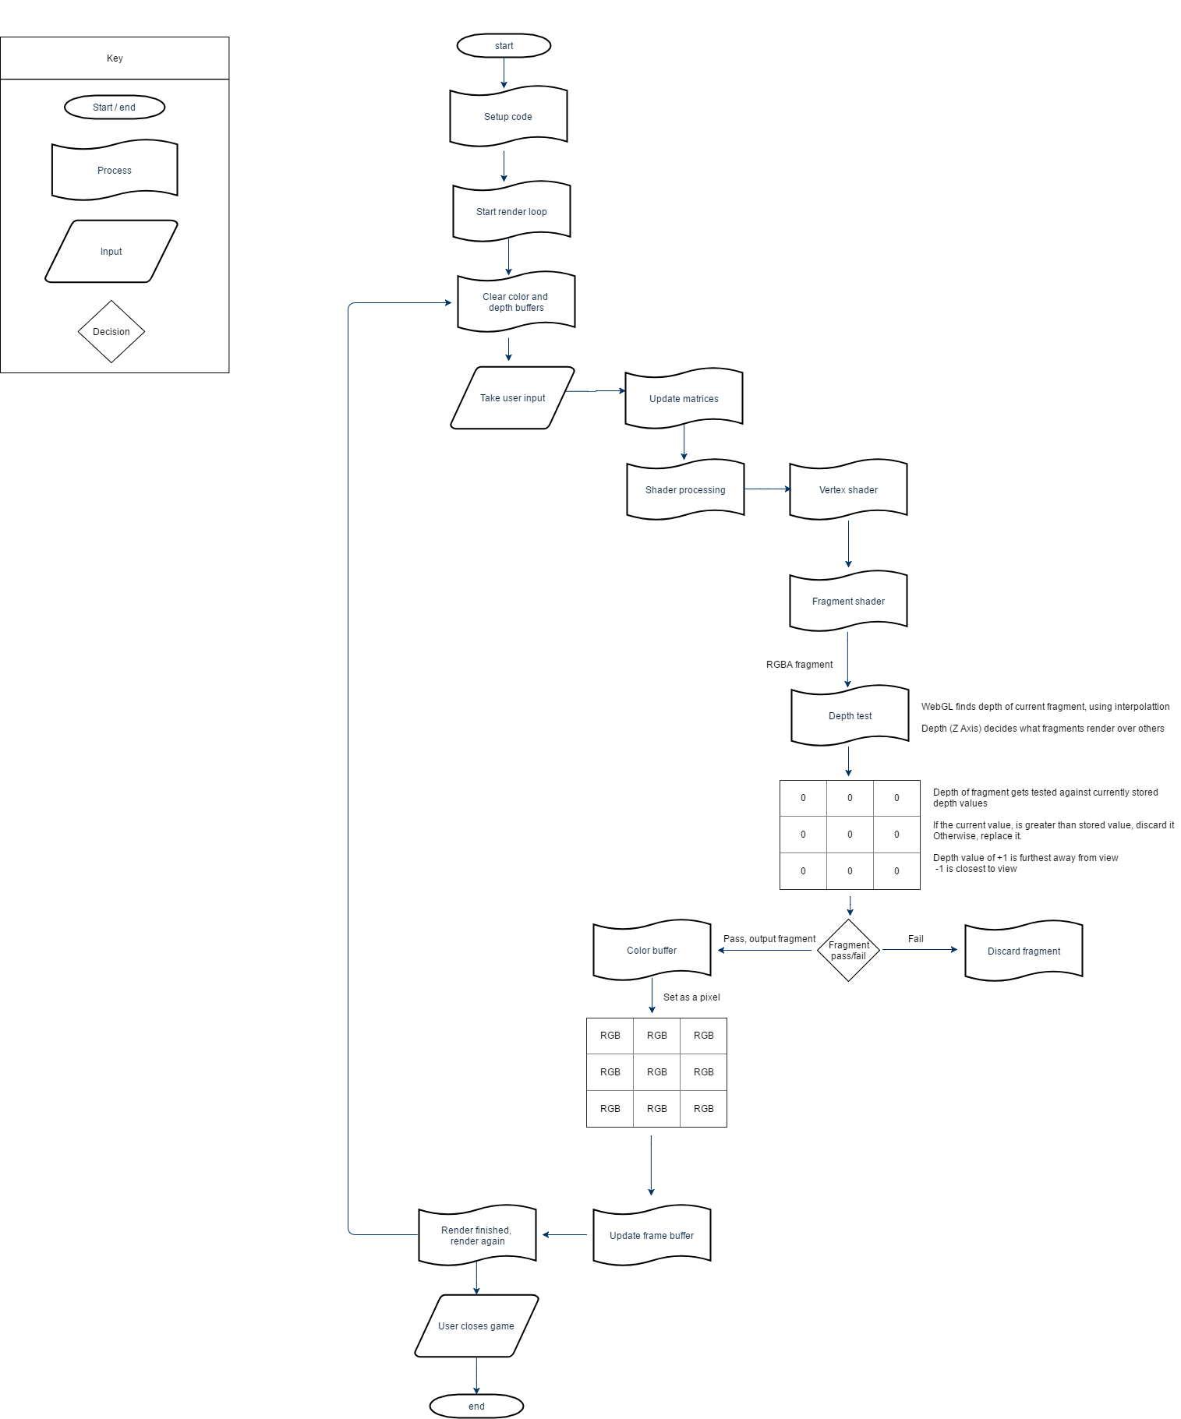

## Detailed Design

// class diagram

### Even More Detail

## User Interface Design

// show screenshots

## Other Relevant Sections

# Implementation

The implementation should look at any issues you encountered as you tried to implement your design. During the work, you might have found that elements of your design were unnecessary or overly complex; perhaps third party libraries were available that simplified some of the functions that you intended to implement. If things were easier in some areas, then how did you adapt your project to take account of your findings?

It is more likely that things were more complex than you first thought. In particular, were there any problems or difficulties that you found during implementation that you had to address? Did such problems simply delay you or were they more significant?

You can conclude this section by reviewing the end of the implementation stage against the planned requirements.

In the mid project demonstration, I realized I did not enjoy creating the game aspects of the project. There were 2 different things I was working on: the game code written in JavaScript and the graphics code in WebGL. Since the graphics were what I was interested in, writing thousands of JavaScript lines to create a game was not interesting. The games aspects also took so long to write and because of this, the graphics of the game suffered. Mid-way through the project I decided to strip out all the game aspects and just focus on the graphics.

// explain graphics pipeline, and shaders, vert/frag

Graphics pipeline

-how to get some data to appear on the screen

-example data, triangle coordinates

3d description of world, turn it into a 2d image

Moving from, easy to think about it, have a model, put into the world, view from a camera, display on screen.

model to world, world to view, view to projection

model has own origin at centre, own coordinate system, origin of triangle

scaling, rotating, translating, its now in world coordinate space (T,R,S)

clipping happens in worldsapce, removing a piece of somethiong from pipeline, we cant see it, clip a triangle loses a vertex, how do drw it with 2 points? Need to create new points along the edge, and split it into separate triangles

culling excludes entire object

WORLD SPACE above (2nd stage)

We define camera in the world, it has a position

Now world to view, need to shift entire world infront of camera, which doesn’t exist, program as if it does, easy to think about

Camera space, everything relative to camera, camera is at 0,0

View to projection

Geometry in screen space, map traingles to screen pixels, rasterization

Generates fragments

Process fragments,

Build image, replacing fragments

Depth buffer, stores depth per pixel

Specifify colour information for every vertex, rather than every fragment. Colour doesn’t vary much across object, blending with interpolation will look ok. Calculating at every fragment, not worth it

// need to create a context to be able to talk to webgl, and get it tointeract with the hardware

// Show initial screenshot, in 1st week,

// quickyl

# Testing

Detailed descriptions of every test case are definitely not what is required here. What is important is to show that you adopted a sensible strategy that was, in principle, capable of testing the system adequately even if you did not have the time to test the system fully.

Provide information in the body of your report and the appendix to explain the testing that has been performed. How does this testing address the requirements and design for the project?

How comprehensive is the testing within the constraints of the project? Are you testing the normal working behaviour? Are you testing the exceptional behaviour, e.g. error conditions? Are you testing security issues if they are relevant for your project?

Have you tested your system on “real users”? For example, if your system is supposed to solve a problem for a business, then it would be appropriate to present your approach to involve the users in the testing process and to record the results that you obtained. Depending on the level of detail, it is likely that you would put any detailed results in an appendix.

The following sections indicate some areas you might include. Other sections may be more appropriate to your project.

## Overall Approach to Testing

// use testing document for this

## Automated Testing

### Unit Tests

// in code

### User Interface Testing

// show screenshots

### Stress Testing

// show high rock count, big terrain size,

// load times

// memory

### Other Types of Testing

// acceptance testing for UI

## Integration Testing

// rendering components in order, terrain to generate rock render indices

## User Testing

// get people to test it? What they liked or didnt

# Critical Evaluation

Examiners expect to find in your dissertation a section addressing such questions as:

* Were the requirements correctly identified?
* Were the design decisions correct?
* Could a more suitable set of tools have been chosen?
* How well did the software meet the needs of those who were expecting to use it?
* How well were any other project aims achieved?
* If you were starting again, what would you do differently?

Other questions can be addressed as appropriate for a project.

Such material is regarded as an important part of the dissertation; it should demonstrate that you are capable not only of carrying out a piece of work but also of thinking critically about how you did it and how you might have done it better. This is seen as an important part of an honours degree.

There will be good things and room for improvement with any project. As you write this section, identify and discuss the parts of the work that went well and also consider ways in which the work could be improved.

In the latter stages of the module, we will discuss the evaluation. That will probably be around week 9, although that differs each year.

// look into some debugging ide, or use directX for useful tools

// horrible amounts of time starting at unhelpful webgl errors, offscreen erros in attriubte 0

// Midway through the project I realized Webgl not properly documented, few tutorials for advanced features, no tools to help debug

# Appendices

The appendices are for additional content that is useful to support the discussion in the report. It is material that is not necessarily needed in the body of the report, but its inclusion in the appendices makes it easy to access.

For example, if you have developed a Design Specification document as part of a plan-driven approach for the project, then it would be appropriate to include that document as an appendix. In the body of your report you would highlight the most interesting aspects of the design, referring your reader to the full specification for further detail.

If you have taken an agile approach to developing the project, then you may be less likely to have developed a full requirements specification. Perhaps you use stories to keep track of the functionality and the ’future conversations’. It might not be relevant to include all of those in the body of your report. Instead, you might include those in an appendix.

There is a balance to be struck between what is relevant to include in the body of your report and whether additional supporting evidence is appropriate in the appendices. Speak to your supervisor or the module coordinator if you have questions about this.

* 1. Third-Party Code and Libraries

If you have made use of any third party code or software libraries, i.e. any code that you have not designed and written yourself, then you must include this appendix.

As has been said in lectures, it is acceptable and likely that you will make use of third-party code and software libraries. If third party code or libraries are used, your work will build on that to produce notable new work. The key requirement is that we understand what is your original work and what work is based on that of other people.

Therefore, you need to clearly state what you have used and where the original material can be found. Also, if you have made any changes to the original versions, you must explain what you have changed.

As an example, you might include a definition such as:

**Apache POI library** – The project has been used to read and write Microsoft Excel files (XLS) as part of the interaction with the client’s existing system for processing data. Version 3.10-FINAL was used. The library is open source and it is available from the Apache Software Foundation [5]. The library is released using the Apache License [6]. This library was used without modification.

Libraries: (give link and licesnse, like above)

JQuery for singular pop up message

m4.js matrix library

perlin library

webgl obj loader for rocks

twgl library for one file

dat.min for ui

stats for fps/memory

From Terrain.js, the createQuadrantIndices function. Answer with 11 upvotes.

<http://stackoverflow.com/questions/5915753/generate-a-plane-with-triangle-strips>

Creates triangle strip indices from a set of vertices.

From MarsScene.js, the resize function. https://webglfundamentals.org/webgl/lessons/webgl-resizing-the-canvas.htm

* 1. Ethics Submission

This appendix includes a copy of the ethics submission for the project. After you have completed your Ethics submission, you will receive a PDF with a summary of the comments. That document should be embedded in this report, either as images, an embedded PDF or as copied text. The content should also include the Ethics Application Number that you receive.

* 1. Code Samples

This is an example appendix. Include as many appendices as you need. The appendices do not count towards the overall word count for the report.

For some projects, it might be relevant to include some code extracts in an appendix. You are not expected to put all of your code here - the correct place for all of your code is in the technical submission that is made in addition to the Final Report. However, if there are some notable aspects of the code that you discuss, including that in an appendix might be useful to make it easier for your readers to access.

As a general guide, if you are discussing short extracts of code then you are advised to include such code in the body of the report. If there is a longer extract that is relevant, then you might include it as shown in the following section.

Only include code in the appendix if that code is discussed and referred to in the body of the report.

Random Number Generator

The Bayes Durham Shuffle ensures that the pseudo random numbers used in the simulation are further shuffled, ensuring minimal correlation between subsequent random outputs.

// Some example code here…

# Annotated Bibliography

This final section should list all relevant resources that you have consulted in researching your project. Each reference should also include a brief annotation.

1. Sylvia Duckworth. A picture of a kitten at Hellifield Peel. <http://www.geograph.org.uk/photo/640959>, 2007. Copyright Sylvia Duckworth and licensed for reuse under a Creative Commons Attribution-Share Alike 2.0 Generic Licence. Accessed August 2011.  
     
   This is my annotation. I should add in a description here.
2. Mark Neal, Jan Feyereisl, Rosario Rascunà, and Xiaolei Wang. Don’t touch me, I’m fine: Robot autonomy using an artificial innate immune system. In *Proceedings of the 5th International Conference on Artificial Immune Systems*, pages 349–361. Springer, 2006.   
     
   This paper…
3. W.H. Press et al. *Numerical recipes in C*. Cambridge University Press Cambridge, 1992.  
     
   This is my annotation. I can add in comments that are in **bold** and *italics*and then further content.
4. Various. Fail blog. <http://www.failblog.org/>, August 2011. Accessed August 2011.  
     
   This is my annotation. I should add in a description here.
5. Apache Software Foundation (2014) “*Apache POI - the Java API for Microsoft Documents*” (Online) Available at: <http://poi.apache.org> Accessed: 14th March 2014.
6. Apache Software Foundation (2004) “Apache License, Version 2.0” (Online) Available at: <http://www.apache.org/licenses/LICENSE-2.0> Accessed: 14th March 2014.